**Methods of Graphical online programming**

1.First connect the micro:bit to the computer with the data cable. At this time, the computer will have a micro:bit U disk. Open the USB flash drive and click on the micro:bit URL as shown in Figure1-1 below to enter the micro:bit official website. You can enter this web address directly in your browser: http://microbit.org/.

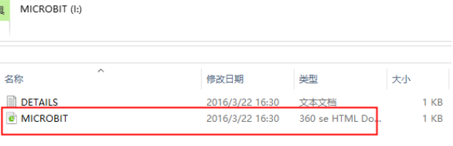

Figure1-1

2.After successfully entering the URL, we can click on the English at the top ri-ght of the interface as shown in Figure1-2 below to switch the language of the entire interface.



Figure1-2

3.If you don't need to switch languages, continue to click [Let's code] at the top of the interface shown in Figure 1-3. At this point we will enter a new interface.

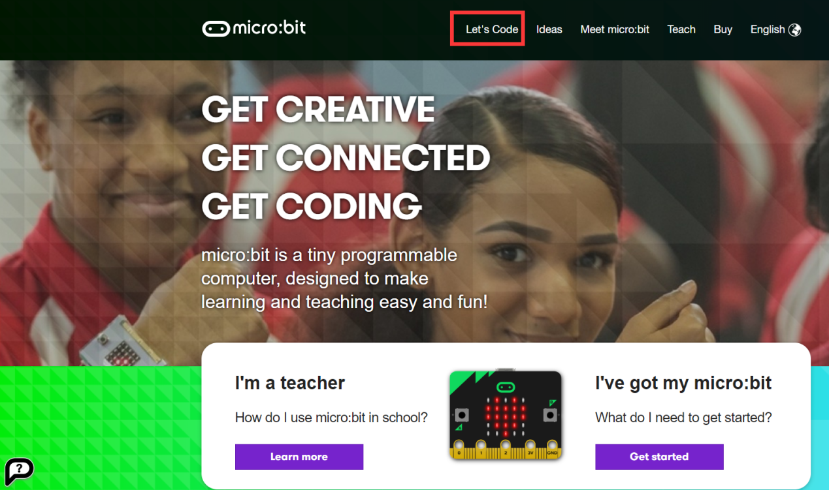

Figure1-3

4. After entering a new page, click [Let's code] at the bottom of the interface shown in Figure1-4 below, and you will be able to enter the MakeCode editor.

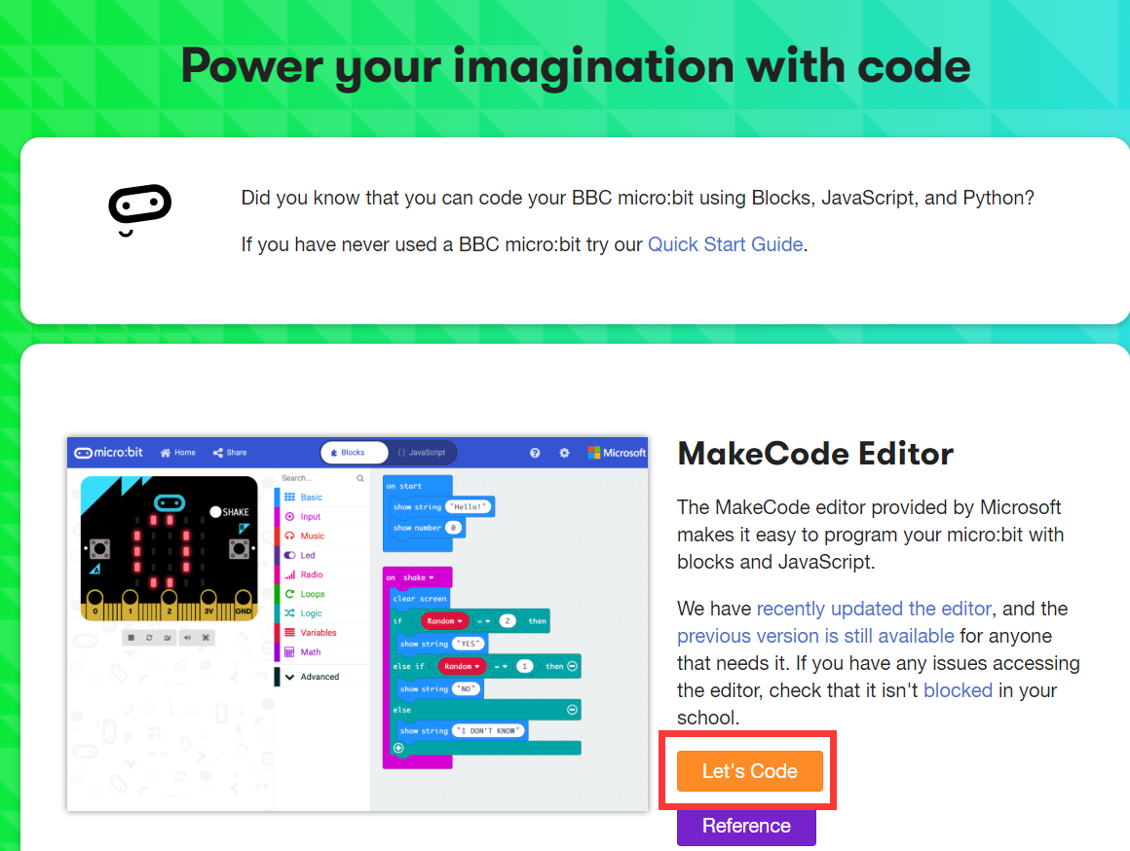

Figure1-4

5.After clicking, we will enter the interface shown in Figure1-5 below. We need to click [New Project] in the lower left corner to enter the MakeCode editor.

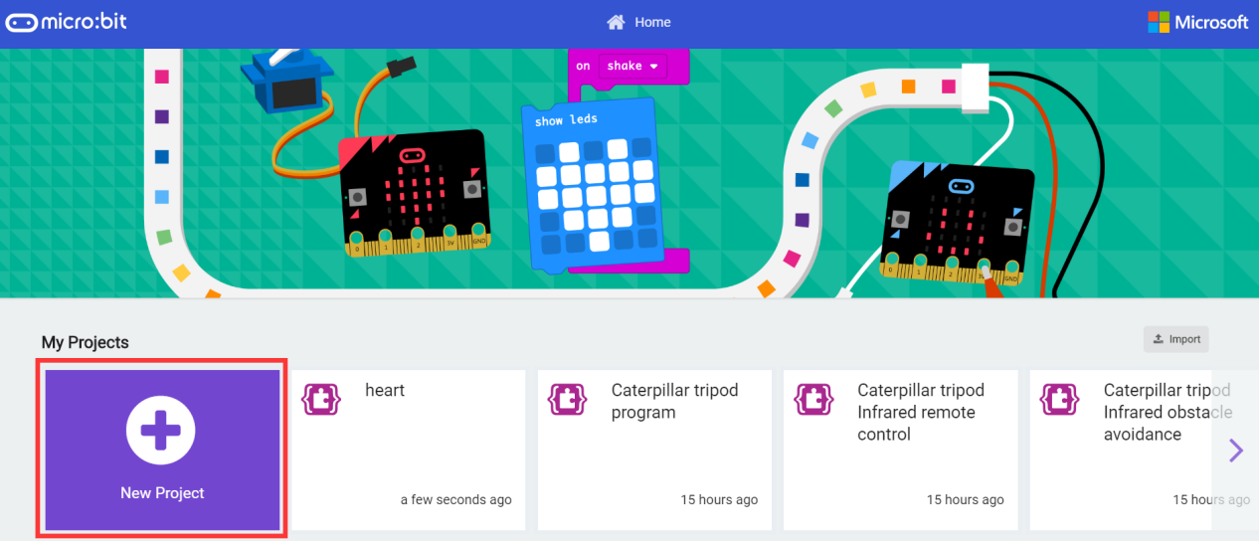

Figure1-5

6. The interface shown in Figure1- 6 below is the micro:bit online programming interface we need to use.

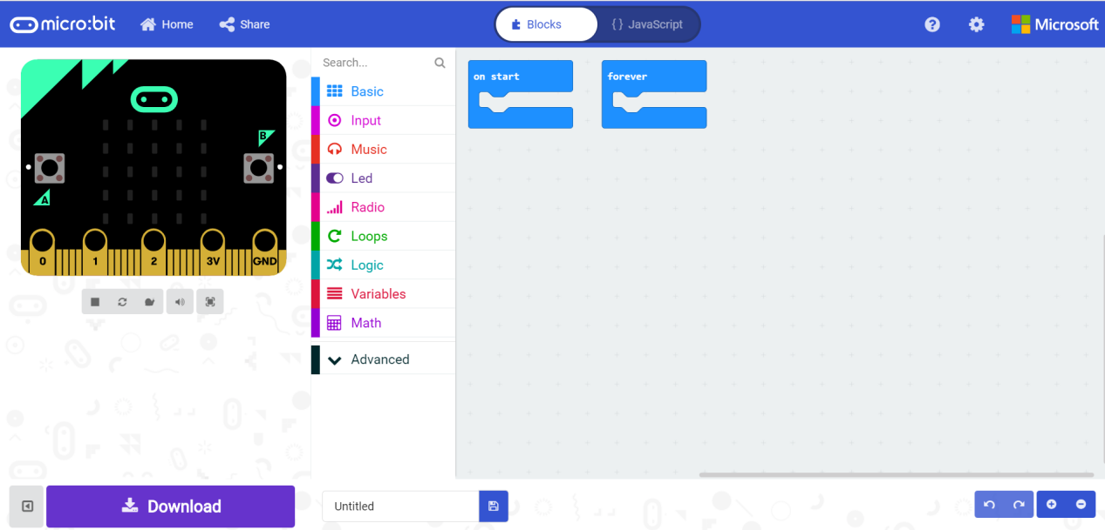

Figure1-6

7.We need to add the Yahboom package. In the interface shown in Figure 1-7 below, click [Advanced], then click [Extensions], an interface will pop up.

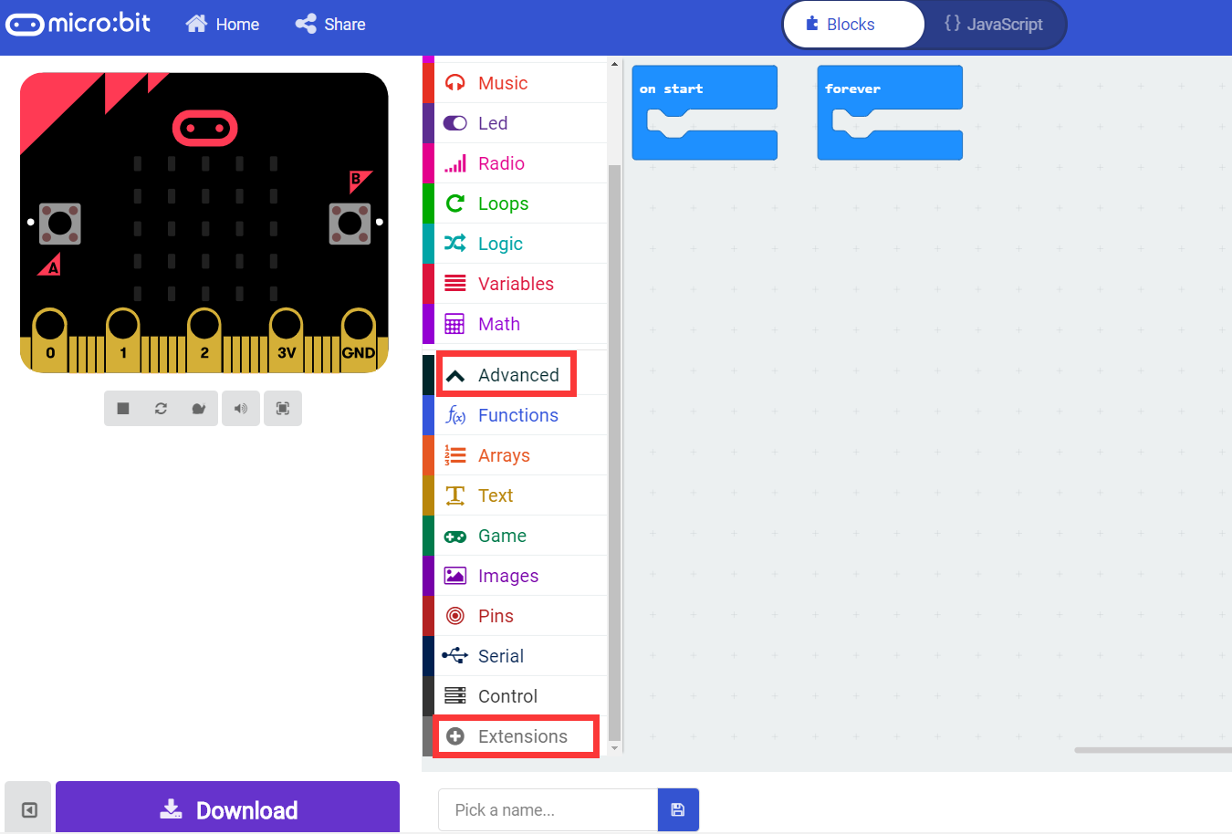

Figure 1-7

8.Enter the URL in the input field of the pop-up interface: **https://github.com/lzty634158/YB_Piano**. Then click the  icon on the right or press the "Enter" key on the keyboard, as shown in Figure 1-8. You can search for the software Yahboom package, and then click piano, as shown in Figure 1-9, you can successfully add the software package.

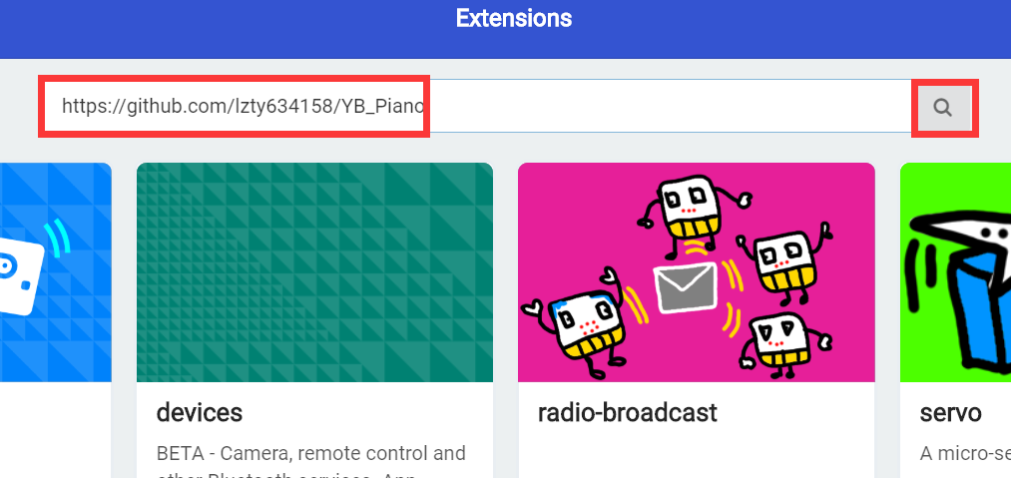

Figure 1-8

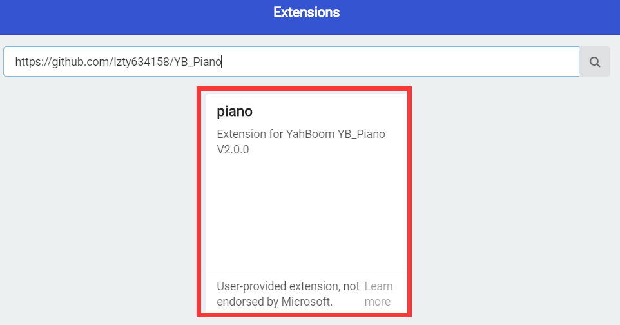

Figure 1-9

9. After loading the package, we can see that the program bar has loaded the building blocks made by Yahboom, as shown in Figure 1-10.

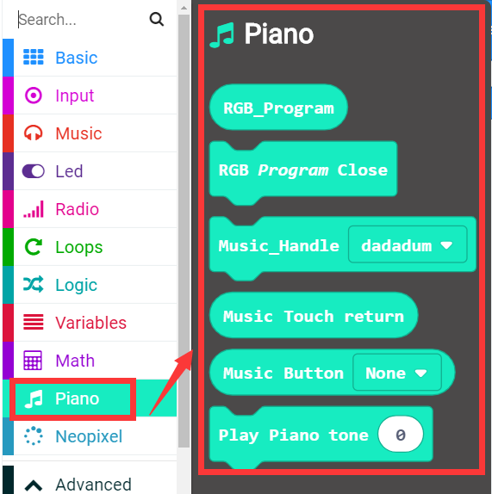

Figure 1-10

10.You can build your own building blocks for programming. After setting up the program blocks, we can set a name for the program, and then click 【Download】 to download the program, as shown in Figure 1-11. We can set the download path to a micro:bit U disk, or you can download it directly to your computer and copy it to the micro:bit U disk.

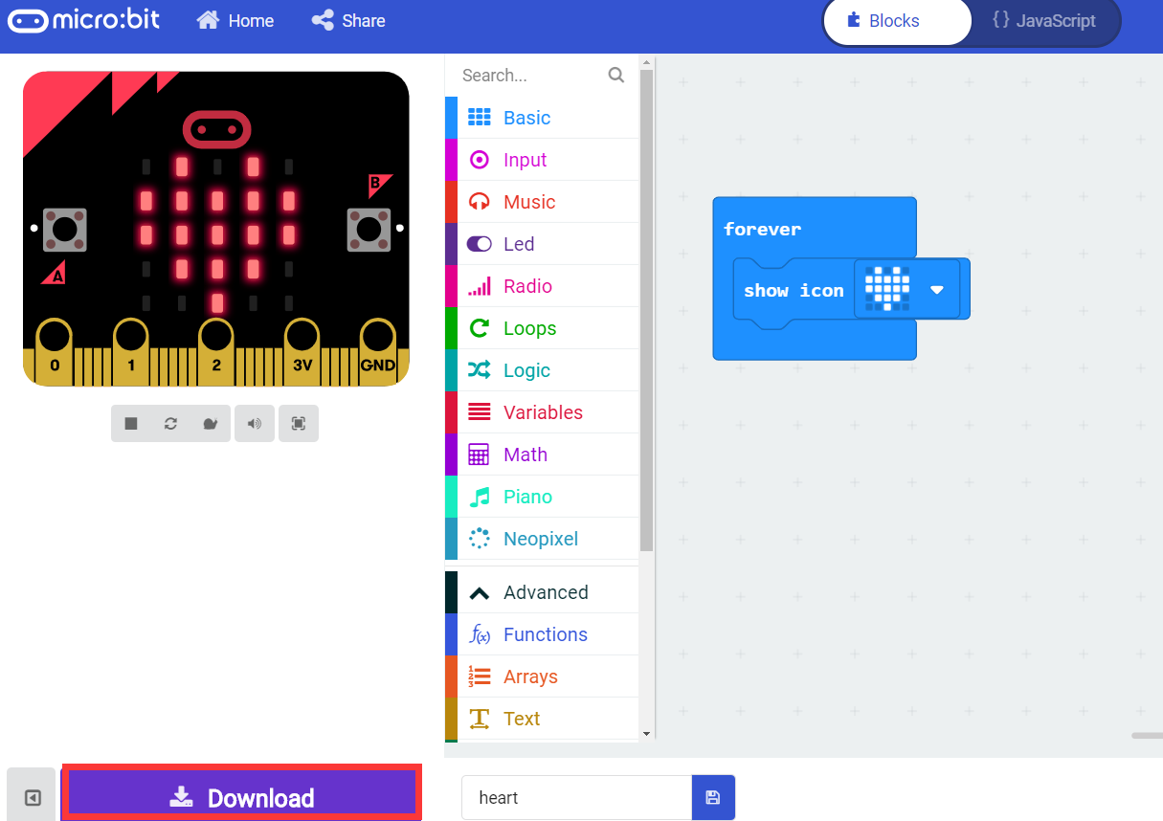

Figure 1-11

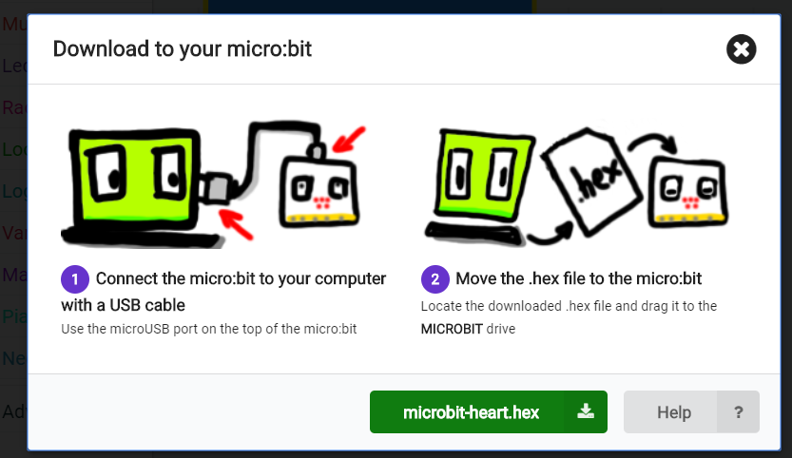

Figure1-12-1

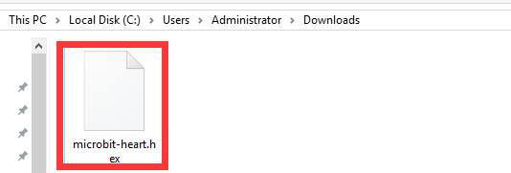

Figure1-12-2

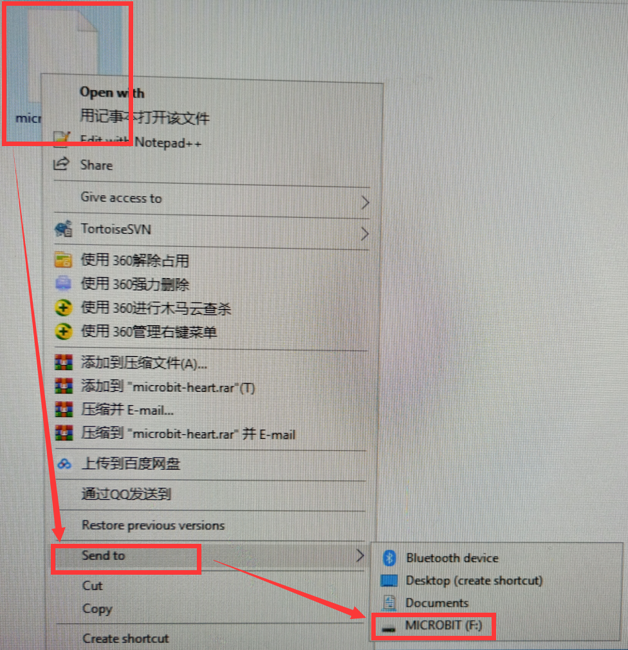

Figure1-12-3

11.During the download, the indicator light on the back of the micro:bit board will flash. After the download is complete, the indicator light stops flashing and we can see the corresponding experimental phenomena and effects.